ACTIVITY -9

Abbas khan A

192224145

1.ABSTRACT CLASS

#include<iostream>

#include<iostream>

#include<string>

using namespace std;

class animal

{

public:

virtual void eat()=0;

};

class dog:public animal

{

public:

void eat()

{

cout<<"dog eats bones";

}

};

class cat:public animal

{

public:

void eat()

{

cout<<"cat eats food"<<endl;

}

};

int main()

{

cat c1;

dog d1;

c1.eat();

d1.eat();

return 0;

}

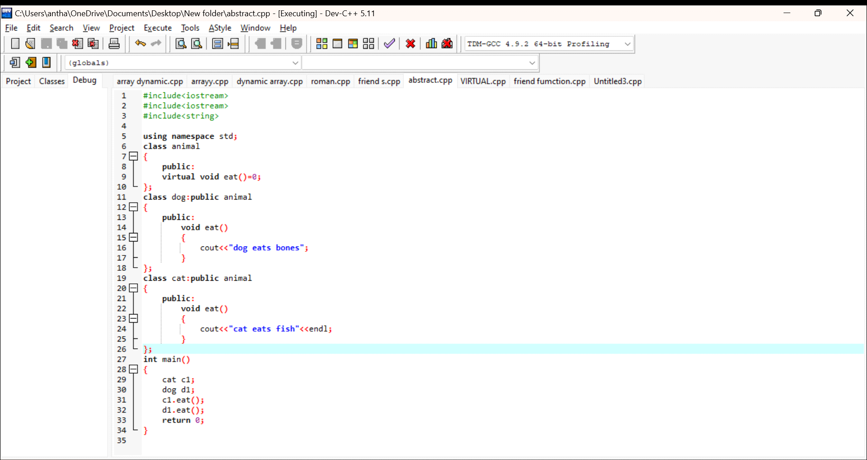

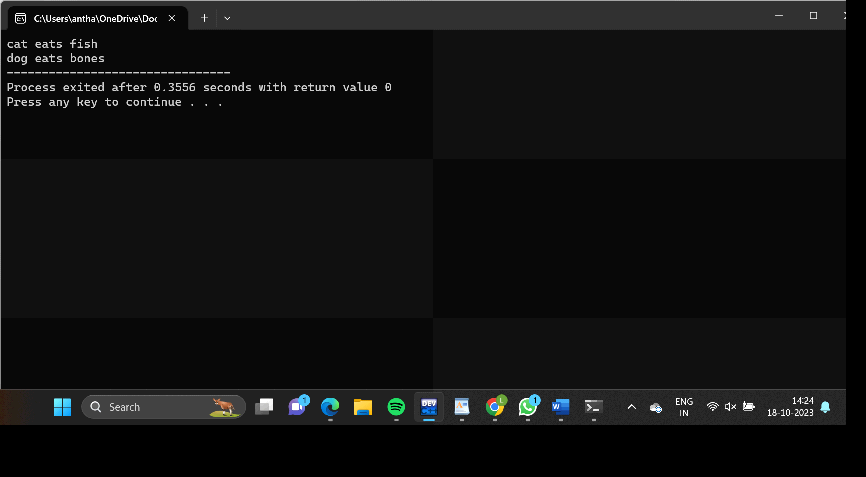

2.OPERATOR OVERLOADING USING FRIEND FUNCTION

#include<iostream>

using namespace std;

class B;

class A

{

public:

int a;

A()

{

cout<<"enter a:"<<endl;

cin>>a;

}

friend void operator+(A,B);

friend void operator -(A,B);

friend void operator \*(A,B);

friend void operator /(A,B);

};

class B

{

public:

int b;

B()

{

cout<<"enter b:"<<endl;

cin>>b;

}

friend void operator+(A,B);

friend void operator -(A,B);

friend void operator \*(A,B);

friend void operator /(A,B);

};

void operator+( A A1, B B1)

{

cout<< "addition"<<A1.a+B1.b<<endl;

}

void operator -(A A1,B B1)

{

cout<<"subtraction"<<A1.a-B1.b<<endl;

}

void operator \*(A A1,B B1)

{

cout<<"multiplication"<<A1.a\*B1.b<<endl;

}

void operator /(A A1,B B1)

{

cout<<"division"<<A1.a/B1.b<<endl;

}

int main()

{

A t;

B s;

t+s;

t-s;

t\*s;

t/s;

}

